PROJECT REPORT

ON

**MEDICAL INVENTORY SYSTEM**

2021

----------------------------------------

**PYTHON PROGRAMMING (INT 213)**

----------------------------------------

Name : Raunak Kumar

Regn_No : 12007198

Program : B.Tech CSE

School : School of Computer Science and Eng.

Date Of Submission : 20 November 2021



**MEDICAL INVENTORY SYSTEM**

**ABSTRACT**

The "Medical Inventory System" has been developed to override the problems prevailing in the practicing manual system. This software is supported to eliminate and, in some cases, reduce the hardships faced by this existing system. Moreover, this system is designed for the particular need of the company to carry out operations in a smooth and effective manner.

The application is reduced as much as possible to avoid errors while entering the data. It also provides error message while entering invalid data. No formal knowledge is needed for the user to use this system. Thus, by this all it proves it is user-friendly. Medical Inventory System, as described above, can lead to error free, secure, reliable and fast management system. It can assist the user to concentrate on their other activities rather to concentrate on the record keeping. Thus, it will help organization in better utilization of resources.

**ACKNOWLEDGEMENT**

I would like to Acknowledge all those without whom this Project would not have been successful. Firstly, I would wish to Thank our Computer Science (PYTHON) Teacher Prof. Sagar Pande who guided me throughout the project and gave his immense support. He made us understand how to successfully complete this project and without him, the project would not have been complete.

This project has been a source to learn and bring out theoretical knowledge to the real-life world. So, I would really acknowledge his help and guidance for this project.

I would also like to Thank my parents who have always been there whenever needed.

Once again, Thanks to everyone for making this project successful.

**INTRODUCTION**

This is a program to manage a Medical Inventory. The Aim of this project is to make the work of the user and management easier by keeping records of different medical goods such as medicines. Through this program we can do a lot of things like : -

1. Any Person can easily search for any type of medicines available he / she wants to purchase.

2. We can also know the details of the available medicines.

3. We can also see the exact prices assigned to every medicines.

4. Admin can use the System to add, delete, update, modify the medicines data available in the database.

5. We can also see the Availability of Medicines through this Program.

**CONTRIBUTION**

Raunak Kumar : -

* GUI (GRAPHICAL USER INTERFACE)
* CODING

* REPORT

**TKINTER**

Tkinter is an open source, portable graphical user interface (GUI) library designed for use in Python scripts.  
Tkinter relies on the Tk library, the GUI library used by Tcl / Tk and Perl, which is in turn implemented in C. Therefore, Tkinter can be said to be implemented using multiple layers.

**Advantages of Tkinter : -**

1. Layered Approach : -

The layered approach used in designing Tkinter gives Tkinter all of the advantages of the TK library. Therefore, at the time of creation, Tkinter inherited from the benefits of a GUI toolkit that had been given time to mature. This makes early versions of Tkinter a lot more stable and reliable than if it had been rewritten from scratch. Moreover, the conversion from Tcl/Tk to Tkinter is really trivial, so that Tk programmers can learn to use Tkinter very easily.

2.Accessibility : -

Learning Tkinter is very intuitive, and therefore quick and painless. The Tkinter implementation hides the detailed and complicated calls in simple, intuitive methods. This is a continuation of the Python way of thinking, since the language excels at quickly building prototypes. It is therefore expected that its preferred GUI library be implemented using the same approach.

3. Portability : -

Python scripts that use Tkinter do not require modifications to be ported from one platform to the other. Tkinter is available for any platform that Python is implemented for, namely Microsoft Windows, X Windows, and Macintosh. This gives it a great advantage over most competing libraries, which are often restricted to one or two platforms. Moreover, Tkinter will provide the native look-and-feel of the specific platform it runs on.

3. Availability : -

Tkinter is now included in any Python distribution. Therefore, no supplementary modules are required in order to run scripts using Tkinter.

**IMPLEMENTATION AND RESULTS (SCREENSHOTS)**

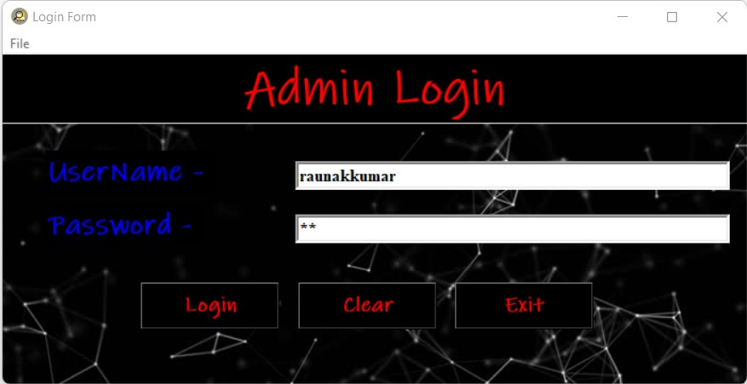**Login Form**

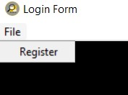

**Registration Form**

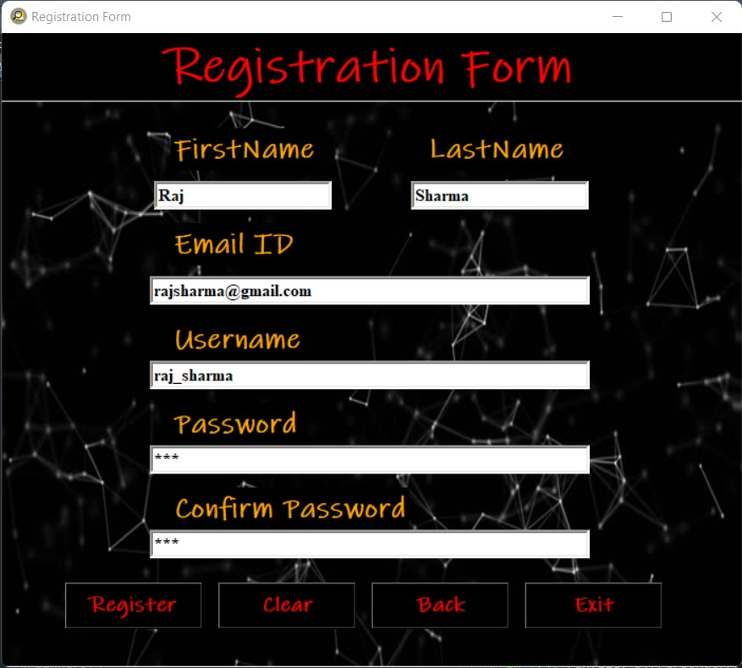

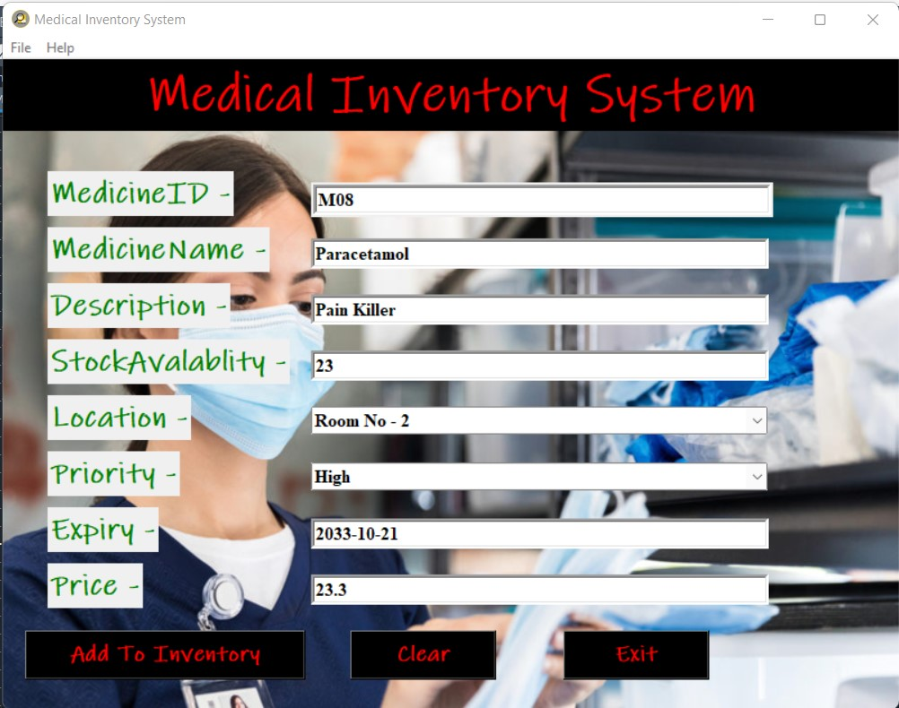**Main Frame**

**Menu’s**

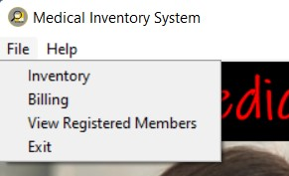

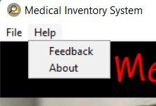

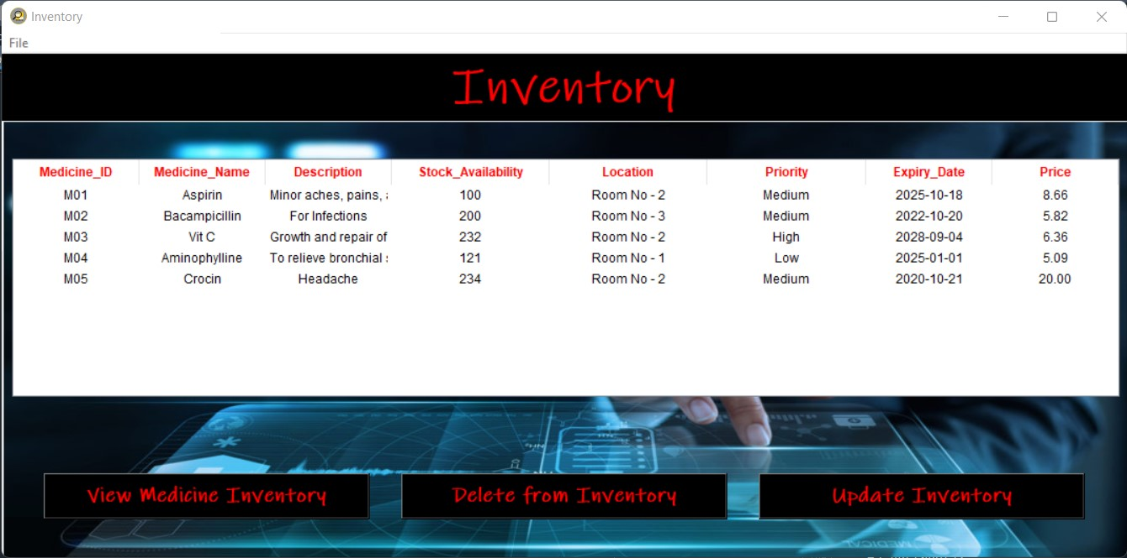**Inventory Frame**

Menu’s

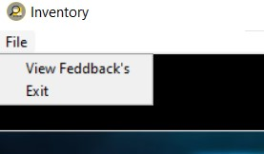

**Feedbacks**

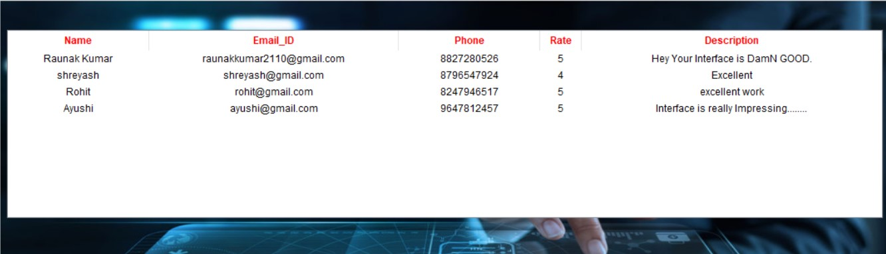

**Billing Frame**

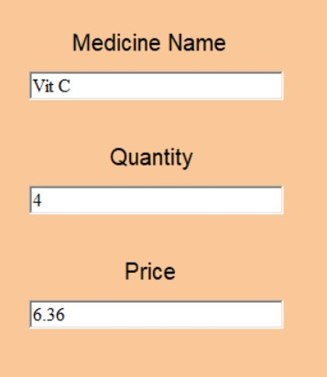

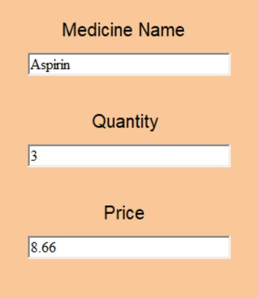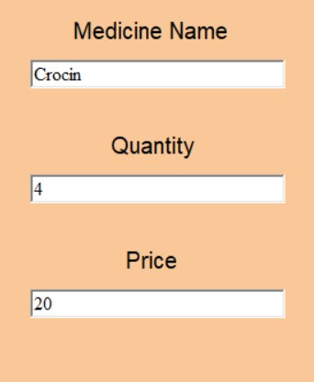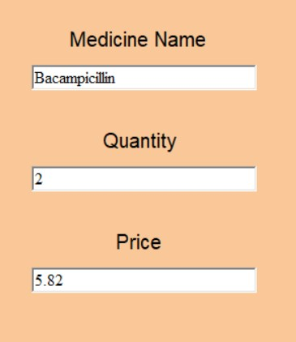

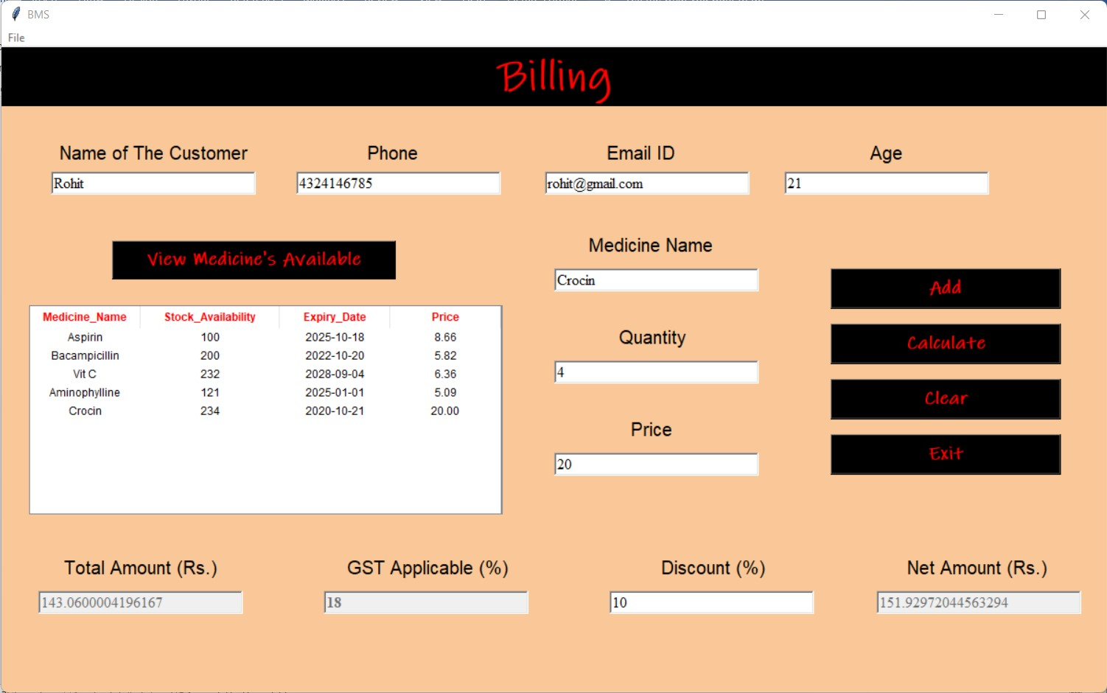

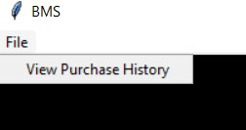

**Purchase History**

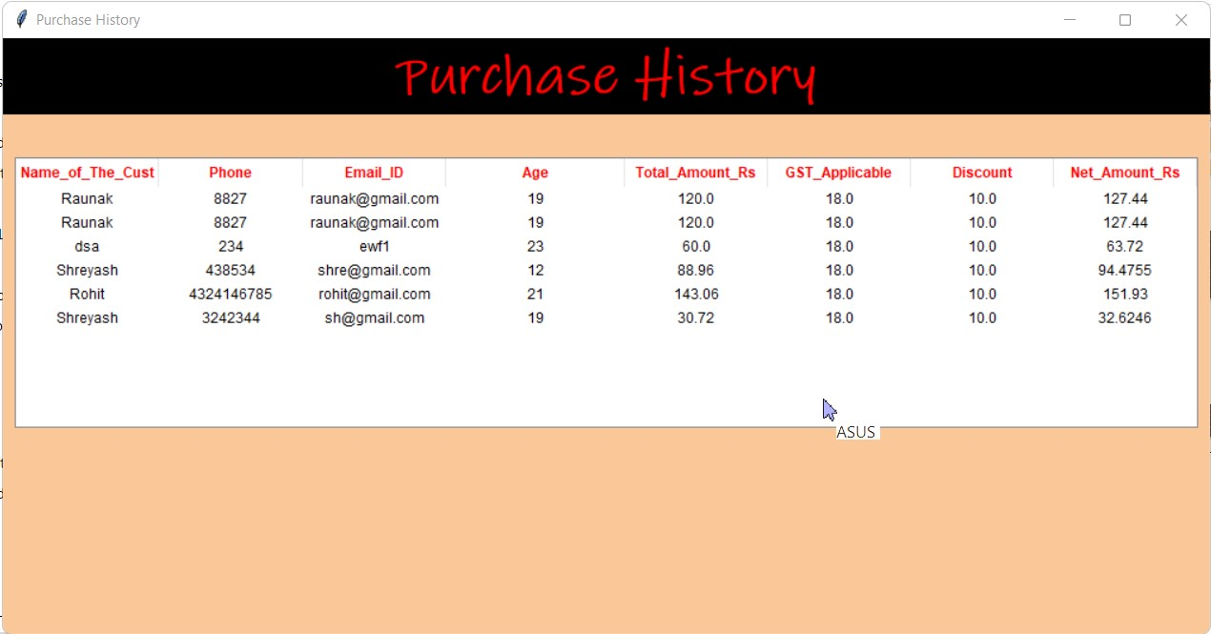

**Registered Member’s Frame**



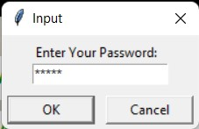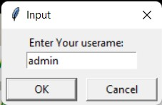

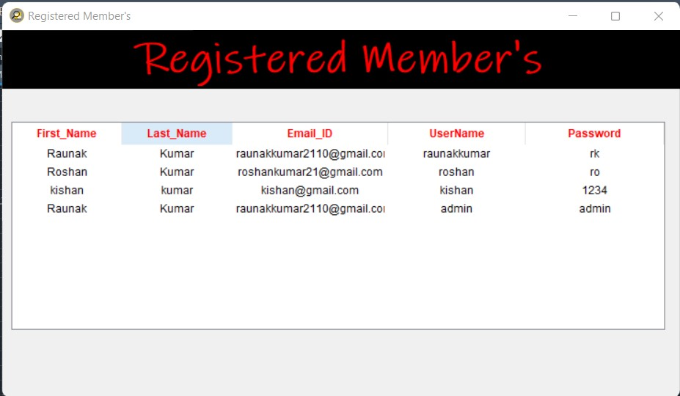

**Feedback Frame**



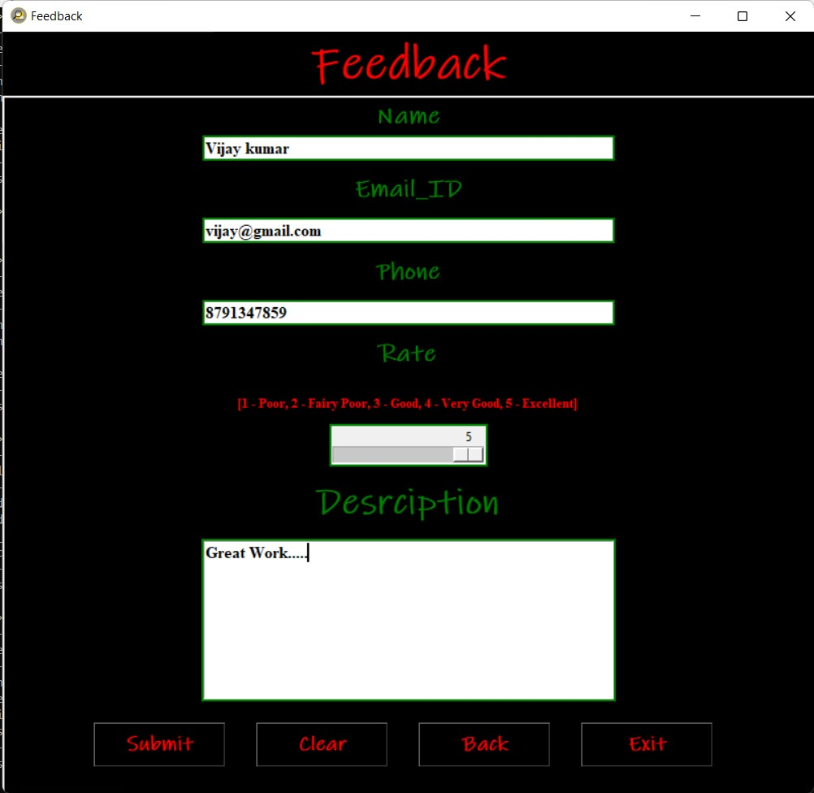

**About Frame**



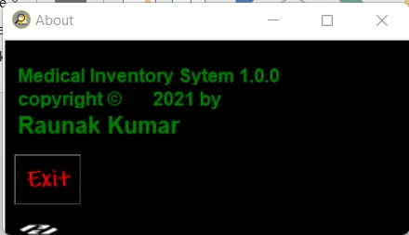

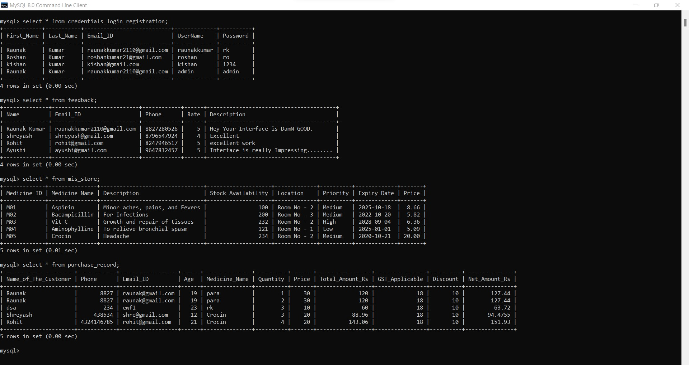**MYSQL Tables**

**MYSQL**

MySQL is a relational database management system (RDBMS) developed by Oracle that is based on structured query language (SQL).

A database is a structured collection of data. It may be anything from a simple shopping list to a picture gallery or a place to hold the vast amounts of information in a corporate network. In particular, a relational database is a digital store collecting data and organizing it according to the relational model. In this model, tables consist of rows and columns, and relationships between data elements all follow a strict logical structure. An RDBMS is simply the set of software tools used to actually implement, manage, and query such a database.

**CODE (SCREENSHOTS)**

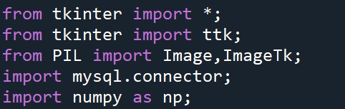

1. from tkinter import * : -

It is used to import all the functions and modules in it.

2. from tkinter import ttk : -

It’s a module which provide access to Tk themed widgets.

3.from PIL import Image, ImageTk : -

The ImageTk module contains support to create and modify Tkinter BitmapImage and PhotoImage.

4.import mysql.connector : -

To create connection to the MySQL server.

5.import numpy as np : -

It is used to import the all functionalities of numpy like multidimensional array and matrix data structure.

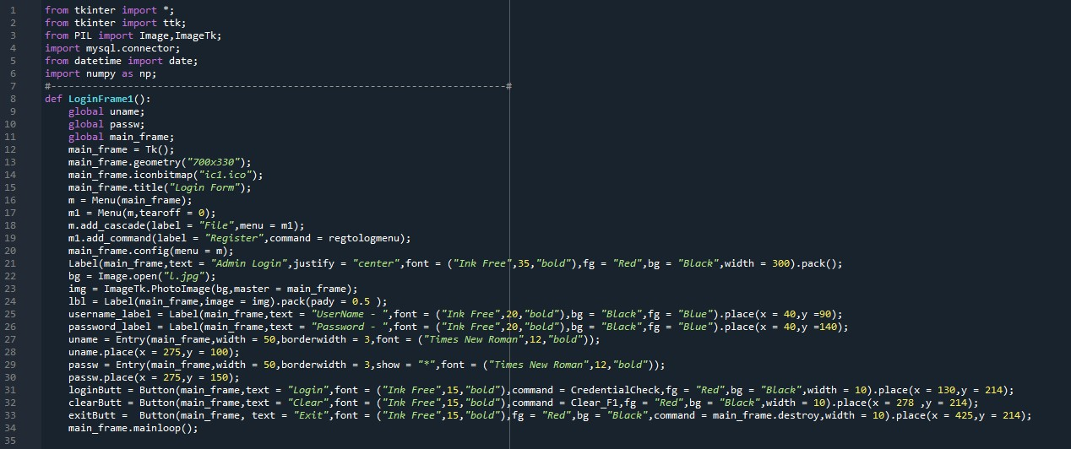

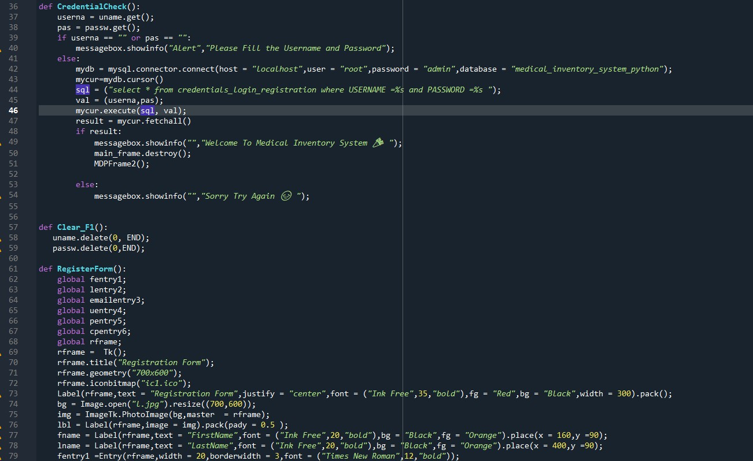

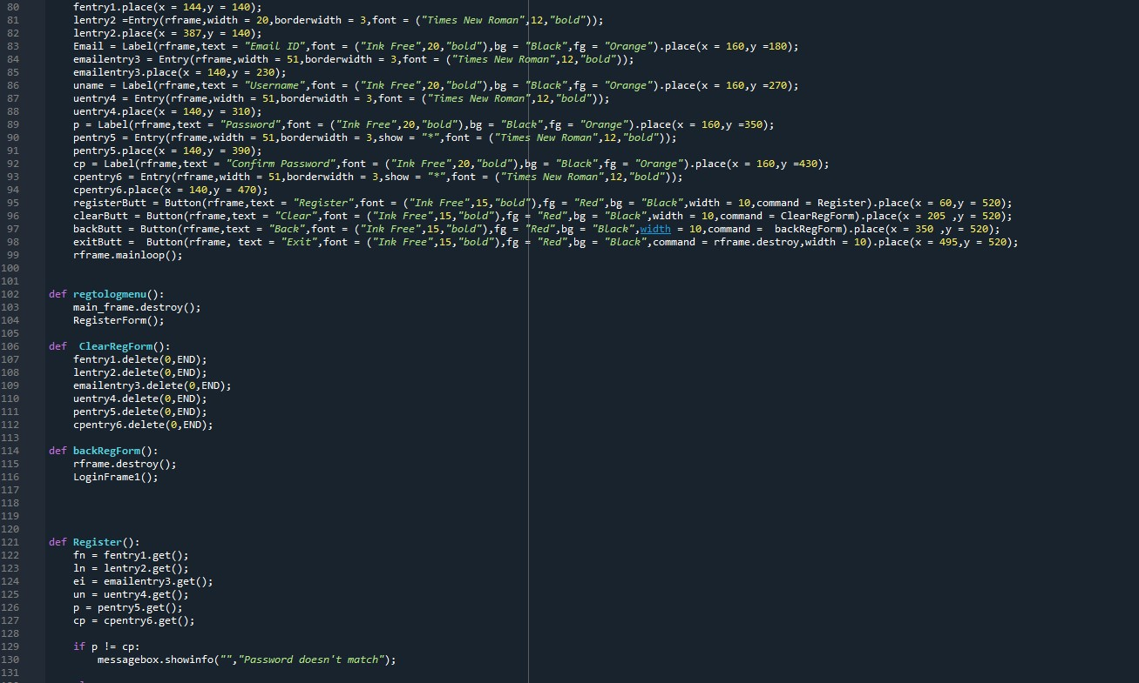

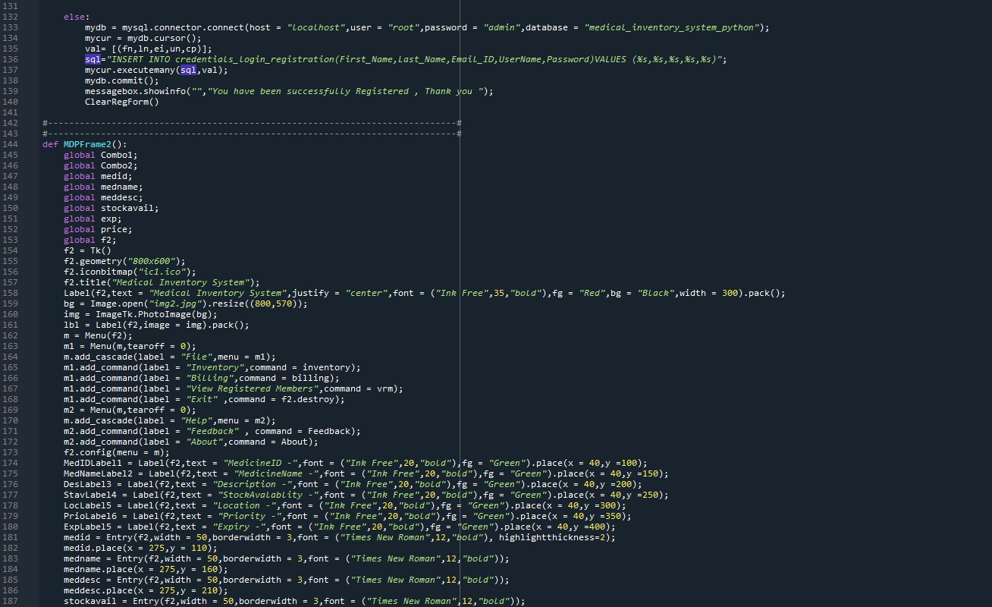

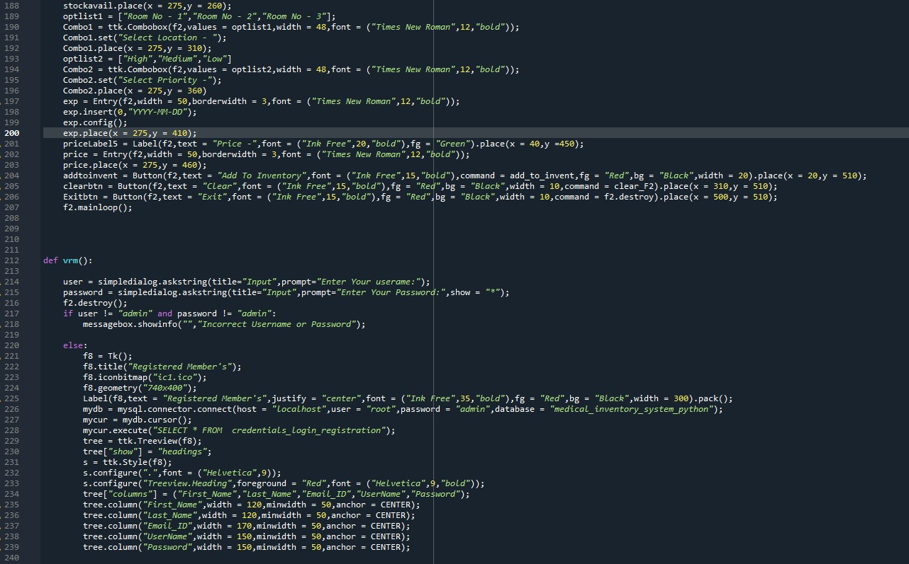

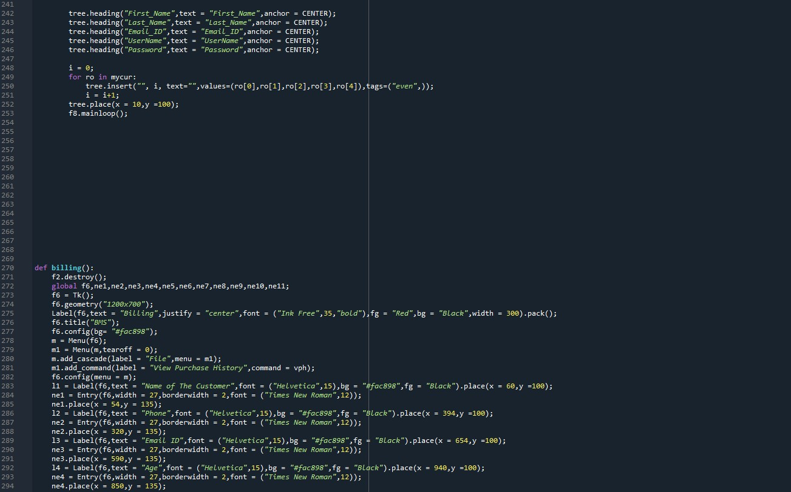

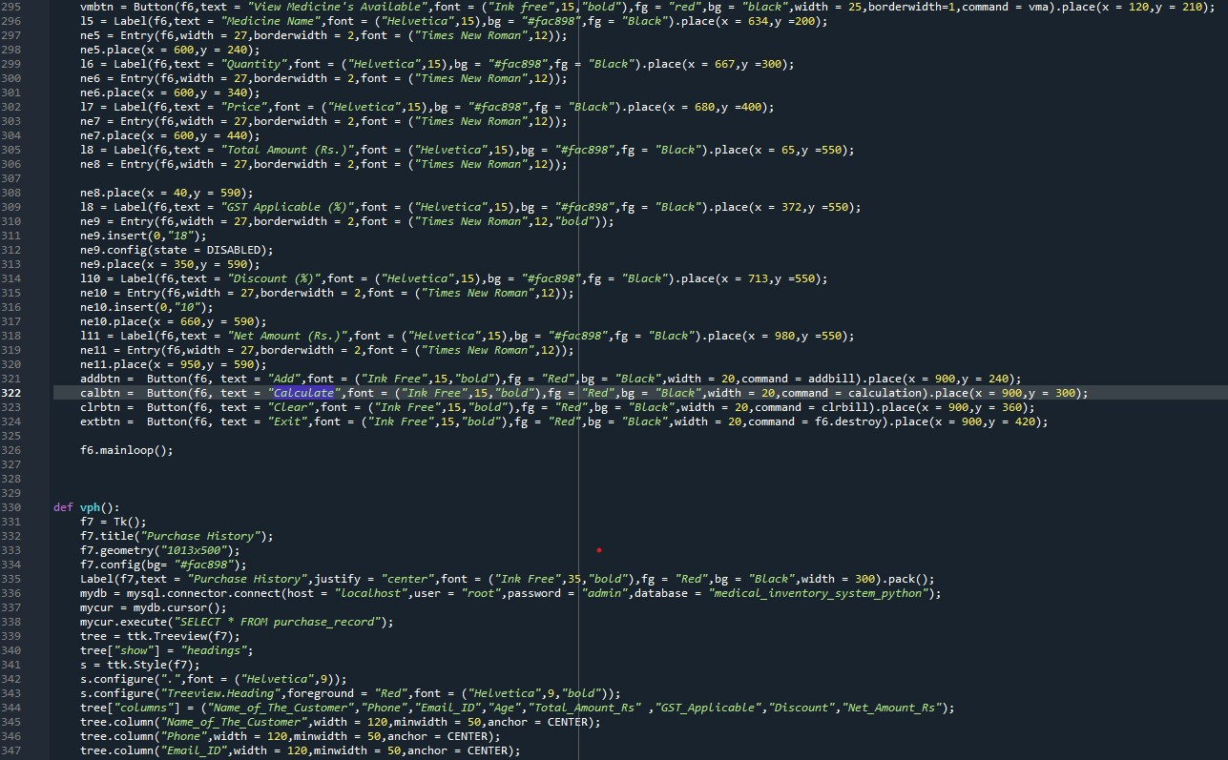

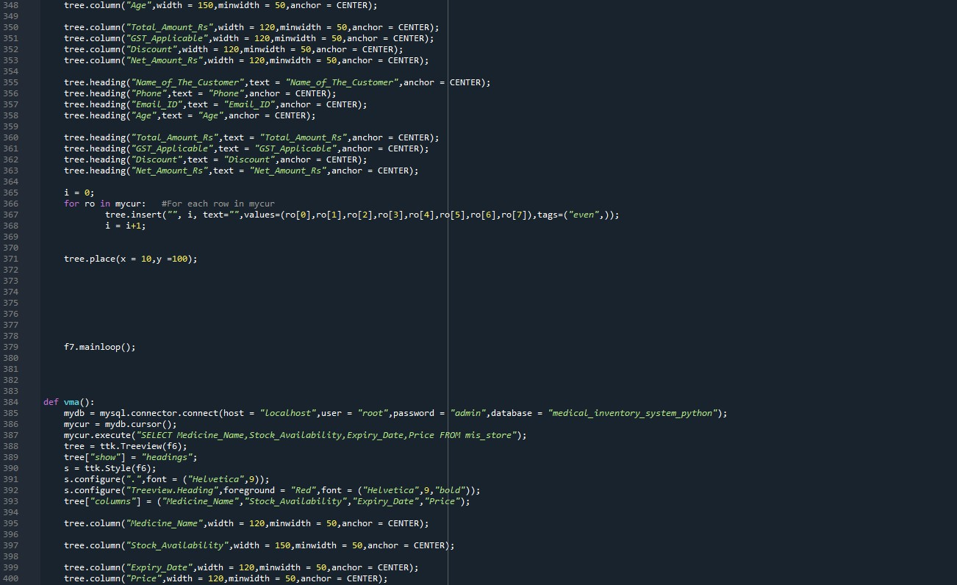

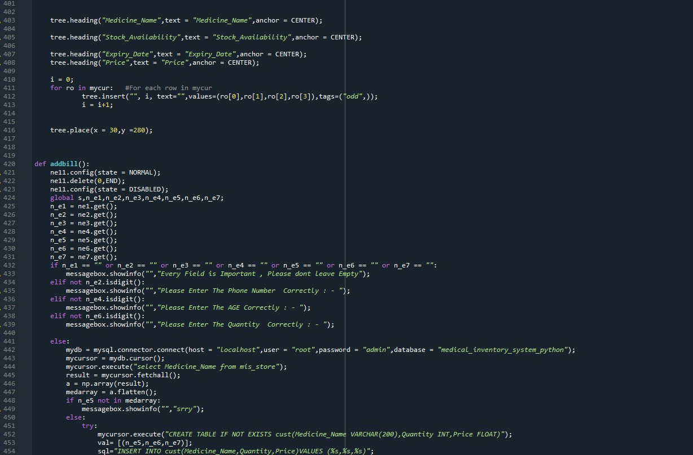

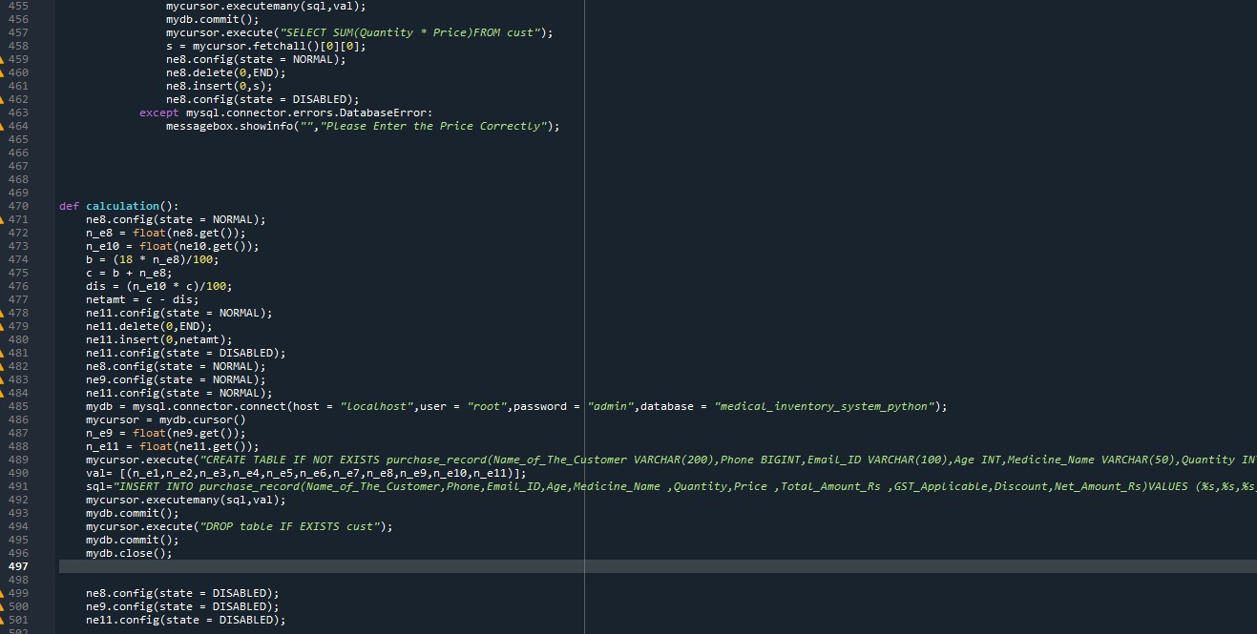

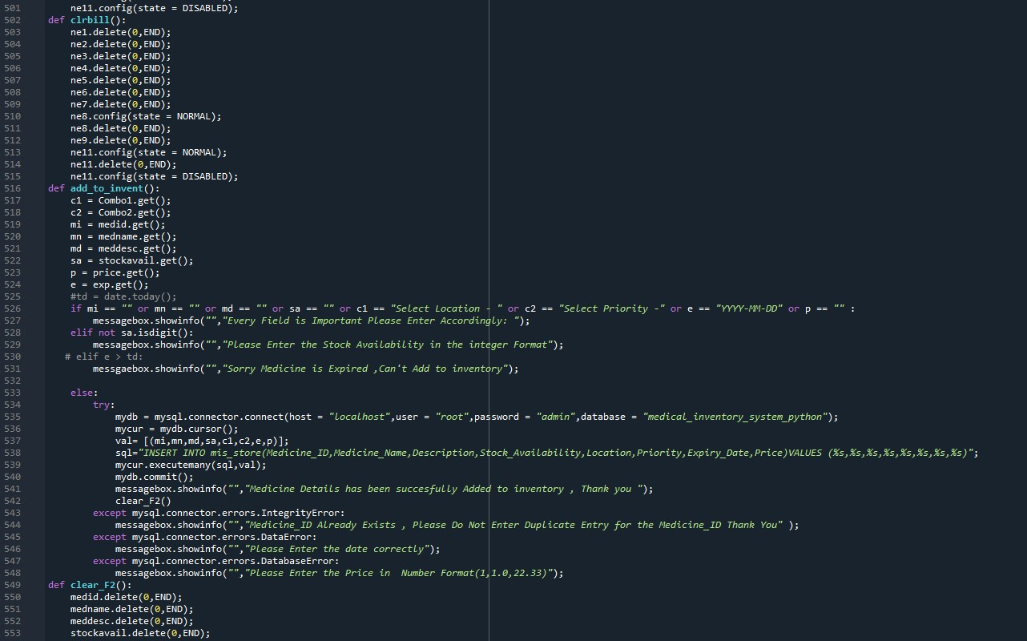

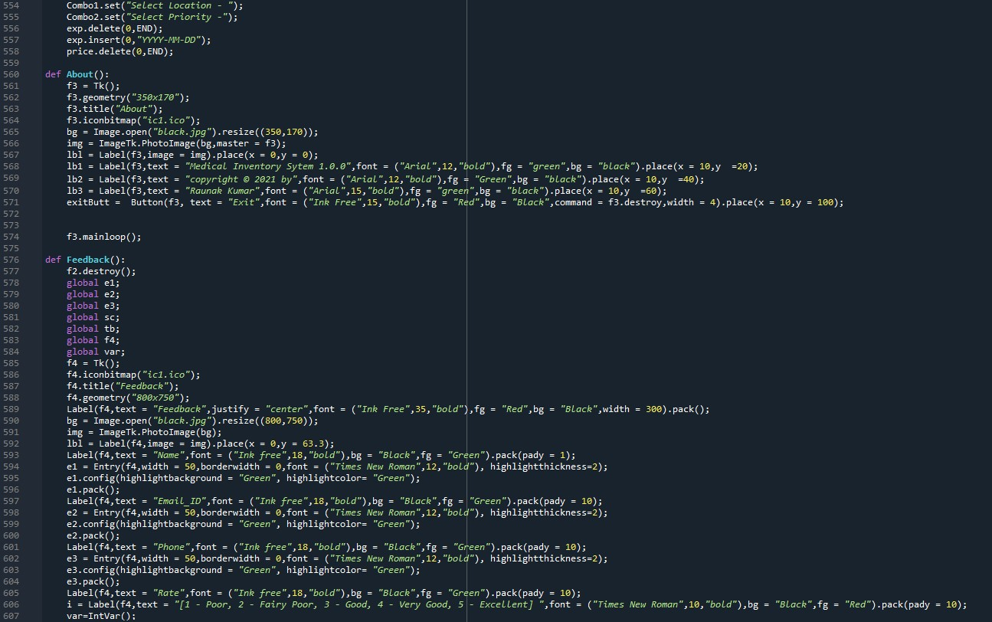

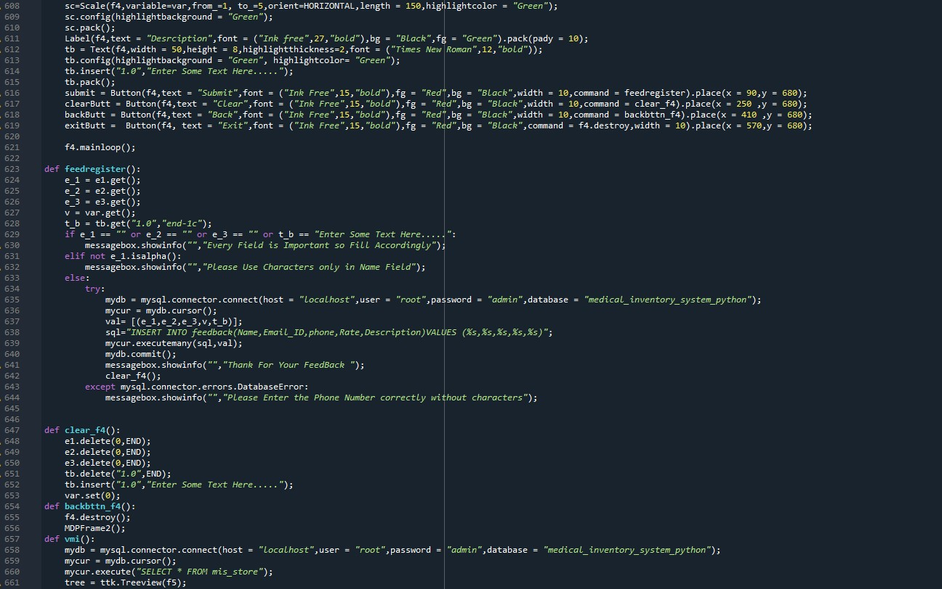

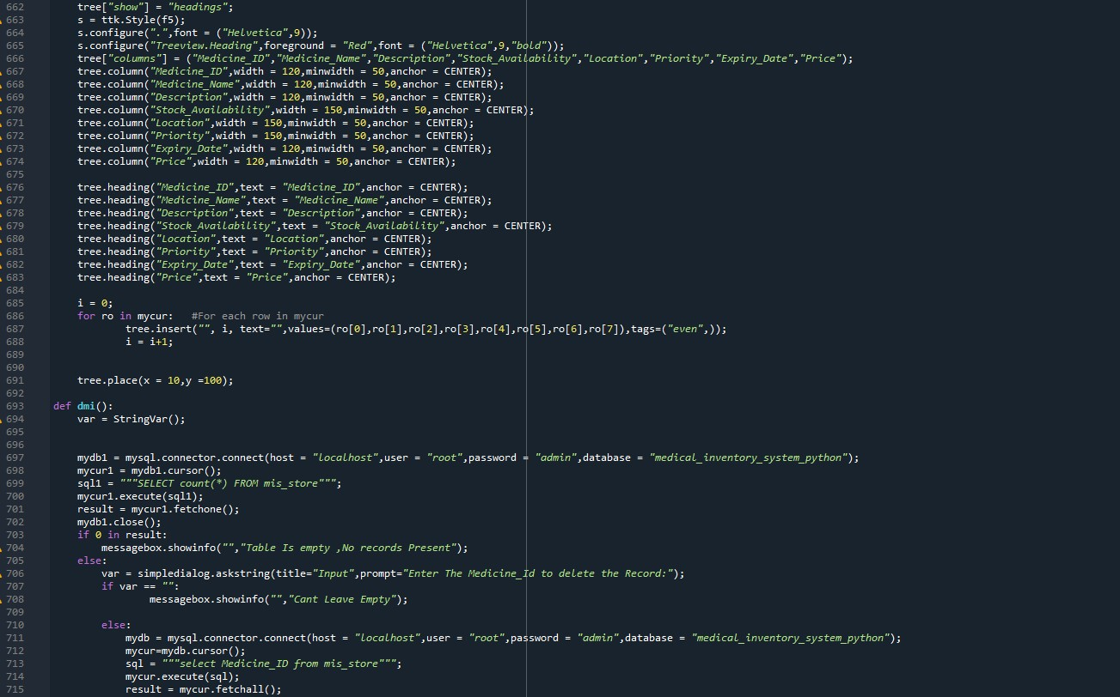

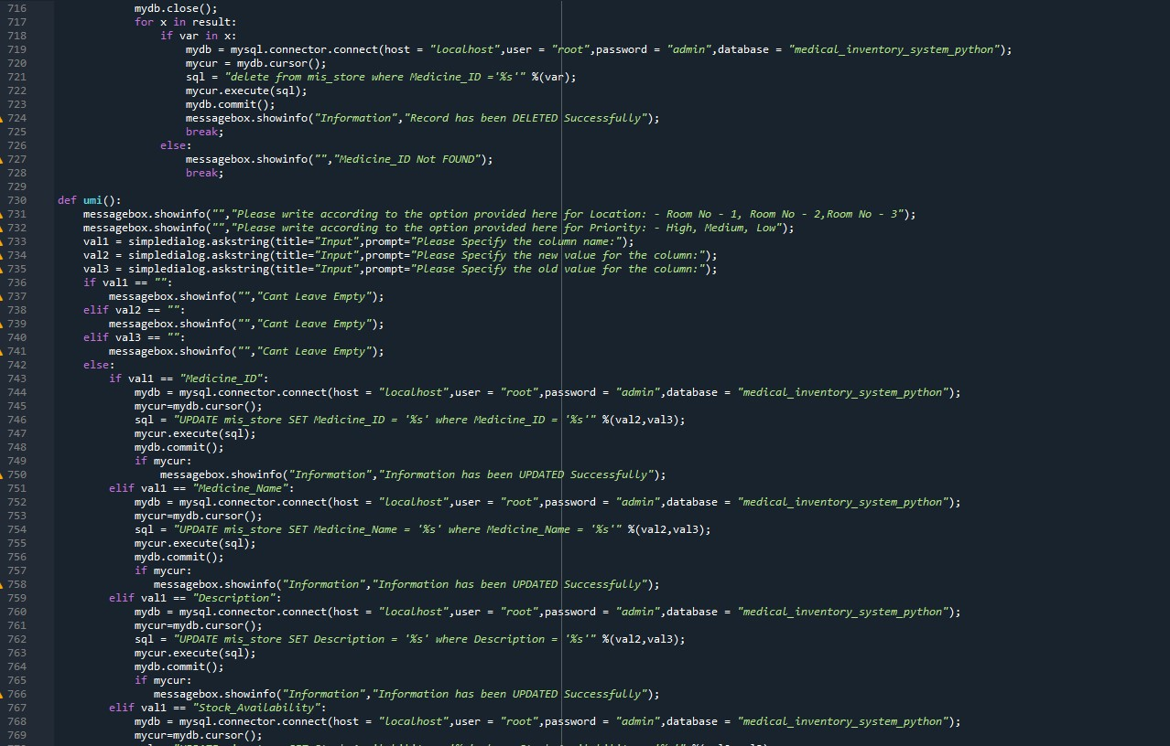

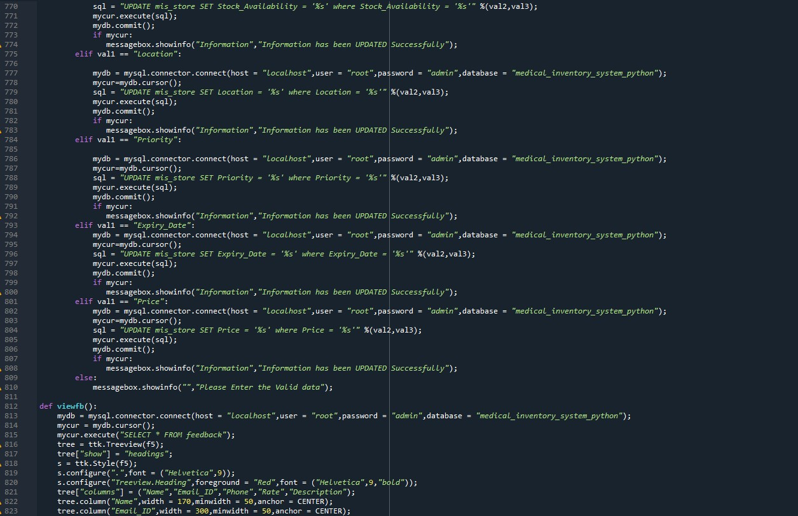

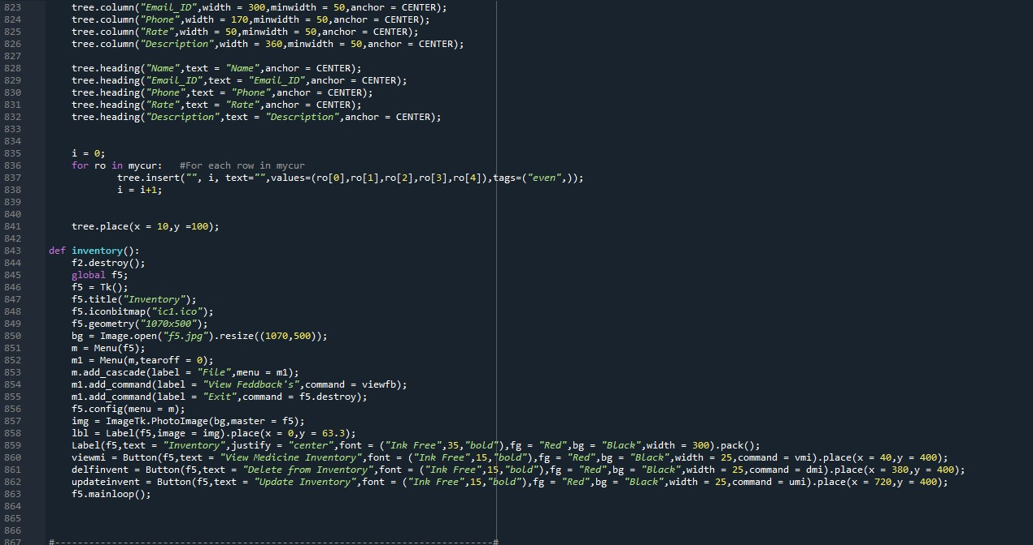

**CONCLUSION**

Effective implementation of this software will take care of the basic requirements of the medical inventory management system because it is capable of providing easy and effective storage of information related to activities happening. This system provides an easy way for the operator to interact with the database and to manipulate the data in the database. The operator can add delete update the records in the database with ease.

**REFERENCES**

* SPYDER (CODING PLATFORM)
* NUMPY (LIBRARY)

<https://numpy.org/>

* STACKOVERFLOW

<https://stackoverflow.com>

* WIKIPEDIA

<https://www.wikipedia.org/>

* W3SCHOOLS

<https://www.w3schools.com/python/python_mysql_getstarted.asp>